###### Assignment Number: 05

**PROBLEM STATEMENT:** Write a menu driven program to perform all string operations (user defined function )

**OBJECTIVE:** To learn string operations in C

**THEORY:**

Strings are actually one-dimensional array of characters terminated by a null character '\0'

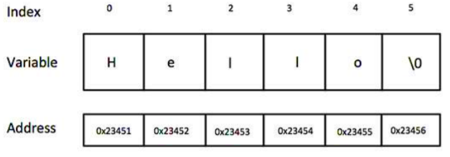

**String Library Functions:**

1. **strcpy(s1, s2);**

Copies string s2 into string s1.

1. **strcat(s1, s2);**

Concatenates string s2 onto the end of string s1.

1. **strlen(s1);**

Returns the length of string s1.

1. **strcmp(s1, s2);**

Returns 0 if s1 and s2 are the same; less than 0 if s1s2.

**User Defined Functions**

**ALGORITHM :**

Step 1: Start

Step 2: Declare/create user defined string functions to compute the **length** of a string, strlength(), to **concatenate** two strings, strconcatenate(), to **compare** two strings, strcompare() and to **copy** a string, strcopy()

Step 3: Declare two arrays of type character, str1[], str2[] and variable c

Step 4: Read strings, str1[], str2[],c

Step 5: Declare switch case statement

switch(c)

case 1: Compute the length of a string with user defined function strlength()

break;

case 2: Concatenate a two strings with user defined function strconcatenate()

break;

case 3: Compare a two strings with user defined function strcompare()

break;

case 4: Copy a one string from another string with user defined function strcopy()

break;

default:

Invalid choice

Step 6: Stop

**FLOWCHARTS:**

**IMPLEMENTATION:**

| **Platform:** 64 –bit Open source Linux  **Technology:** Open Source C++ Programming tool like G++/GCC.  **Input:** String .  **Output:** String after performing |
| --- |

**CONCLUSION:** Thus we have learned various string operations in C.

###### FAQ’s:

1. How to find the maximum occurring character in given String?
2. How to remove all duplicates from a given string?
3. How do you check if a given String is Palindrome or not?